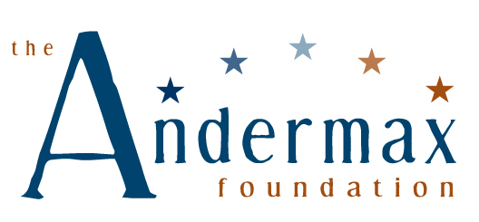

APPLICATION CHECKLIST

DATE:
ORGANIZATION:
INFORMATION TO BE INCLUDED WITH YOUR PROPOSAL:
GENERAL FOR ALL APPLICANTS:
❒ The Andermax Foundation Application Cover Form
❒ 501(c)(3) Ruling Letter
❒ Board of Directors List
❒ Most recent Annual Report
❒ Most recent Audit (form 990 may be substituted if not required to submit an audit)
❒ Organization Budget AND Project/Program Budget (if requesting project support)
❒ Organization’s Major Contributors listing amounts received, committed or pending
NEW GRANT APPLICANTS:
❒ Proposal Narrative including brief history of organization/project, purpose and goals, population and geographic area served, activities needing funding, how the program furthers the Foundation’s mission, and how and when the program results will be measured (five pages or less)
CURRENT GRANTEES (organizations that received funding in the previous grant year):
❒ A two-page narrative detailing organizational or programmatic changes since your last application, external factors impacting your organization, and a description of your organizational and programmatic plans and priorities for the coming year.
❒ A Report Form on your most recent grant if a report has not been submitted in the past three months.
Do NOT send additional materials such as video, newspaper articles, brochures, or letters of support unless requested by the grant committee.
PLEASE NOTE: All applicants who are awarded a grant will be required to submit a report regarding the use of the grant and progress toward stated goals in the program for which the grant was requested.
PLEASE EMAIL YOUR COMPLETE PROPOSAL TO grant@andermaxfoundation.org
ALL APPLICATION MATERIALS MUST BE RECEIVED BY THE DEADLINE.
Application Deadline: February 23, 2012
Grant Notification: June 22, 2012

The Andermax Foundation, PO Box 25012, Woodbury MN 55125

